The Moving Sofa Problem-Finding the Largest Sofa That Can Turn in a Right-Angled Hallway-A problem which has boggled mathematics for year.
The Problem:
Imagine you're trying to move a large, flat sofa around a 90-degree hallway corner. What is the maximum area a sofa can have while still being able to turn in the corner? We seek the shape with the largest possible area that can fit through and rotate around the corner without getting stuck.
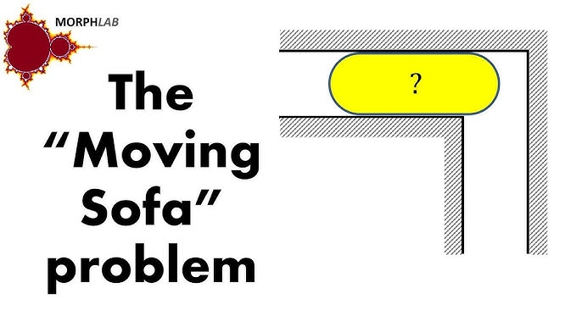
The mathematical concepts required to solve them:
- Geometry: Understanding the Constraints:
- The sofa must fit through both corridors and the corner without rotation exceeding the available space.
- Shapes with curved edges can help optimize movement through the corner.
- Calculus & Variational Optimization:
- The problem can be framed as an area maximization problem under motion constraints.
- The function describing the sofa's boundary must satisfy differential equations that ensure smooth motion around the corner.
- Computational & Numerical Methods:
- Since there is no simple formula for the best shape, researchers use numerical methods and computer simulations to test possible solutions.

Best proposed solutions so far:
1) Gerver’s Sofa (~2.2195 square units):
- Instead of a simple semicircle (like earlier attempts), he designed a more intricate shape with curved and straight sections.
- It consists of piecewise-defined parametric curves, optimized for maximum area.
- The front part has a smooth, rounded shape, while the back has a more complex boundary.
- It allows for smooth translation and rotation as it moves around the corner.
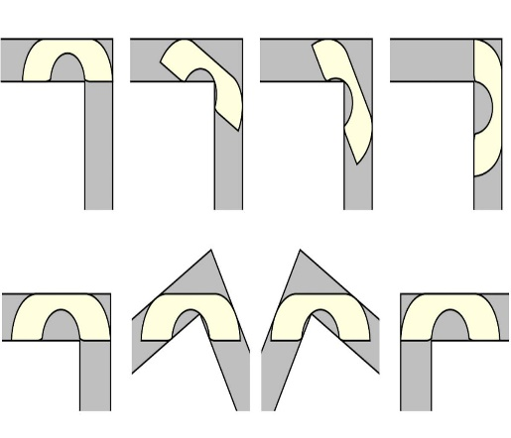
2) Hammersley’s Sofa (Area ≈ 2.2074):
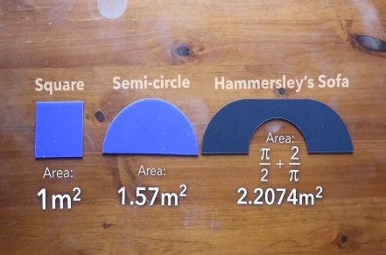
- It was the first serious mathematical attempt to find an optimal solution.
- Hammersley’s sofa consists of a semicircle attached to two straight segments.
- The semicircle has a radius of 1, giving it a natural rounded shape for rotation.
- The straight edges allow for smooth movement into the hallway.

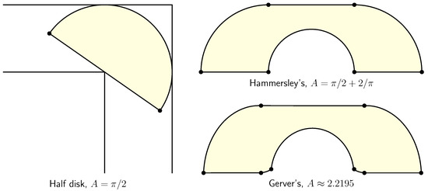
A small comparison of both sofas
Further to be explored:
- The Piano Movers' Problem: A more general version where objects of different shapes move through complex corridors.
- The 3D Version: What happens when we extend this problem of moving a 3D sofa through a 3D hallway?

Haripriya V H,
ECE-I year

